Image-Based 3D Reconstruction of Traditional Thai Pottery

1st Sai Aike Shwe Tun Aung
Vincent Mary School of Science, Engineering and Technology
Suvarnabhumi Campus, Assumption University of Thailand
Samut Prakan, Thailand
u6712122@au.edu
2nd Ekaterina Kazakova
Vincent Mary School of Science, Engineering and Technology
Suvarnabhumi Campus, Assumption University of Thailand
Samut Prakan, Thailand
u672006@au.edu
3rd Kyaw Thi Ha
Vincent Mary School of Science, Engineering and Technology
Suvarnabhumi Campus, Assumption University of Thailand
Samut Prakan, Thailand
u6715088@au.edu

Abstract—This project investigates image-based 3D reconstruction of traditional Thai earthenware for an interactive augmented or virtual reality exhibition. During the current reporting period, the team completed a structured online survey of candidate vessels, cross-checked claimed Thai origins against cultural references, excluded unsuitable or insufficiently verified listings, and selected and ordered two unpainted pottery objects. Selection emphasized both cultural relevance and photogrammetric suitability, including rigid form, matte surfaces, visible texture, and accessible geometry. After delivery, the objects will undergo pilot capture and comparative reconstruction using COLMAP, followed by mesh cleanup in Blender and integration into the course exhibition platform.
Keywords—Thai arts and culture, image-based rendering, photogrammetry, 3D reconstruction, earthenware, COLMAP

Introduction
Image-based reconstruction is a computer vision technique that creates a digital representation of a real object from photographs taken at different angles. It is used in areas like cultural preservation, education, entertainment, augmented reality and virtual reality. Instead of manually building every part of an object, the system estimates its shape and surface appearance from visible information in the images.
This project focuses on reconstructing traditional Thai pottery and water containers. These clay or ceramic containers have been used to store drinking water and water for household activities. Their shapes, materials, surface patterns and production methods can reflect local knowledge and traditional ways of living.
Several Thai cultural objects and themes were considered before this topic was selected. Large buildings and architectural structures were avoided because they require many photographs, outdoor access, and camera positions that may be difficult to reach and record. Small or medium pottery is more affordable, easier to control, and suitable for a project of this scale.
The topic was partly inspired by two team members from Myanmar who are familiar with similar clay water containers. This shared regional and cultural familiarity encouraged the team to study Thai examples while carefully distinguishing them from visually similar pottery traditions. The main goal is to produce textured 3D models of at least two Thai pottery objects from overlapping photographs and present them in an AR or VR environment where users can rotate, scale, and inspect them.

Literature Review
Image-based 3D reconstruction estimates the shape of an object from multiple two dimensional images. Szeliski [1] explains that images captured from different viewpoints can provide information about camera movement, depth and three dimensional structure. The quality of the result depends on factors like image overlap, surface detail, lighting consistency, and camera movement.
Structure from Motion is normally used during the first stage of reconstruction. It detects local features in each photograph and matches the same features across different images. These matches are used to estimate the camera positions and create a sparse set of 3D points. Bundle adjustment then improves the estimated camera parameters and point positions by reducing reprojection error.
Schönberger and Frahm [2] introduced an incremental Structure from Motion approach that was later released as part of COLMAP. COLMAP is now an open source system on GitHub that supports automatic reconstruction, command line processing, graphical visualization, and Python integration. It can produce camera poses, sparse point clouds, dense point clouds, surface meshes, and texture maps.
Multi View Stereo is used after the sparse reconstruction. It estimates depth information for many pixels and combines this information into a dense point cloud. Schönberger and colleagues [3] proposed a pixelwise view selection method that improves depth estimation by selecting appropriate source images. The dense point cloud can then be converted into a triangle mesh.
Meshroom is another open source reconstruction tool based on AliceVision [4]. Its visual workflow is convenient because the major processing stages are displayed as connected nodes. However, COLMAP was selected as the main tool for this project because it offers a simple automatic mode and detailed control when individual steps need to be adjusted. Blender will be used for model cleanup, while Unity or another platform provided by the course professor will be used for the final AR or VR presentation.

Methodology

​​Overall Project Design
The project follows an experimental image-based reconstruction process. At least two real Thai earthenware containers will be photographed from multiple viewpoints after delivery. The photographs will be processed to estimate camera positions, reconstruct object surfaces, generate textures, and create models suitable for real-time visualization.
The work is divided into five general phases. The first phase covers cultural research, candidate screening, and object procurement; this phase has progressed to the ordering of two selected pots. The second phase will focus on delivery inspection, measurement, pilot image capture, and testing. The third phase will cover complete reconstruction using COLMAP. The fourth phase will involve mesh cleanup and optimization. The final phase will place the models inside an AR or VR environment.

The workflow remains intentionally flexible. Photograph counts, software settings, meshing methods, export formats, and presentation tools are current plans rather than fixed requirements. The team will record changes, settings, and results from each attempt so that later decisions are based on measured reconstruction performance.

Cultural Research and Object Selection
During the current reporting period, the team conducted a broad online survey of Thai clay and ceramic water containers rather than purchasing the first available item. Numerous candidate listings were screened by comparing product names, descriptions, visual characteristics, and claimed origins with independent cultural and historical sources. Listings that represented Chinese or Indian styles, generic imported decoration, or objects whose Thai origin could not be reasonably supported were removed from consideration. This produced a smaller candidate set with a more defensible connection to Thai material culture.
The team also reviewed the historical development and functional categories of pottery in Thailand. Thai cultural sources distinguish earthenware from later high-fired stoneware and document household forms such as pots, jars, and water vessels [5], [6]. This review helped the team evaluate candidates as cultural objects rather than treating every terracotta-colored product as Thai pottery.
For each shortlisted object, the team began recording its likely Thai name, region, associated tradition, historical or household use, and supporting cultural source. These details remain under verification and will be updated as stronger sources are found; marketplace labels alone are not being accepted as cultural evidence.
Candidate selection combined cultural verification with photogrammetric suitability. Each shortlisted object was evaluated using the following criteria.
- The object should have a clear connection to Thai culture or traditional household life
- The object should be rigid and should not change shape while being photographed
- The object should be accessible from most viewing directions
- The surface should contain visible texture, carving, color variation, or decorative patterns
- The object should not be highly reflective or transparent
- The object should be affordable, borrowable, or already available to a team member
- The object should be safe to handle and should not be an important religious or historical artifact

Based on this screening, the project scope was expanded from one primary object to at least two pottery objects. Two unpainted Thai earthenware candidates have now been ordered. Reconstructing more than one object will reduce dependence on a single purchase and will allow the team to compare how differences in shape, ornamentation, and surface texture affect feature matching and mesh completeness.
Figure 1 shows one selected candidate. Its unpainted matte surface, carved decorative bands, rigid lid, and opaque clay body are favorable for image matching. At the same time, the rounded, rotationally symmetric body may produce ambiguous matches, while the lid, opening, pedestal, and lower surfaces will require higher and lower camera viewpoints. After delivery, the height, maximum diameter, opening diameter, and base diameter of both pots will be measured for scale correction and accuracy evaluation.

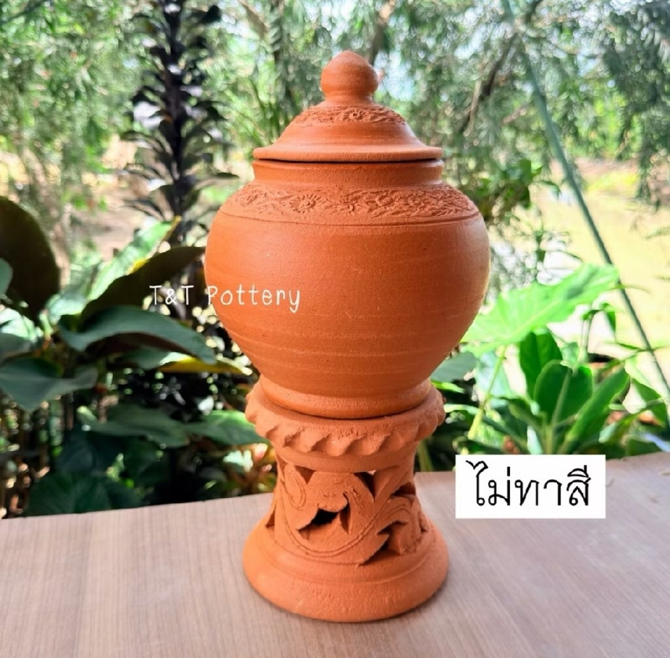
Fig. 1. One of the two unpainted earthenware candidate pots ordered for reconstruction testing. Product image supplied by the team from T&T Pottery.

Equipment and Capture Area
The main equipment will include a smartphone or digital camera, a tripod or camera support, two light sources, white fabric or tracing material for light diffusion, a measuring tape, and several printed reference markers. Most of this equipment can be borrowed from friends or created from inexpensive materials.
The capture area will be set up indoors to prevent changes in sunlight, wind, and background movement. The object will be placed on a stable stool or table. The team will leave enough space around the object for the camera operator to move safely.
The lighting will be placed on opposite sides of the object and covered with diffusing material. This should reduce hard shadows and strong reflections. The position and brightness of the lights will remain unchanged throughout one capture session. Direct flash will not be used.
A lightly textured background will be used instead of a completely plain wall. The background should provide enough features for camera pose estimation without attracting too much attention from the object. Printed markers may be placed on the table and around the capture area. These markers will not be attached directly to the pot.

Camera Preparation
After delivery, each pot will be inspected for damage, loose parts, glare, and areas that may be hidden during capture. The same camera and lens will be used throughout each dataset. Digital zoom, portrait effects, beauty filters, and automatic background blur will be disabled. Focus, exposure, and white balance will be locked when the camera application permits, and test photographs will confirm sharpness and highlight retention before the capture area is disturbed.

Image Acquisition and Dataset Preparation
A pilot dataset of approximately 30 to 40 photographs per object is planned before full reconstruction. The object will remain stationary while the camera moves around it in overlapping middle and upper rings. After reviewing registration and sparse geometry, a complete dataset of approximately 80 to 150 photographs per selected object will be captured using middle, upper, and lower paths as required. Original files will be preserved, while a working set will exclude blurred, duplicated, poorly exposed, or obstructed images. A Python dataset-inspection script is planned to record file names, dimensions, camera metadata, and capture order.

Sparse and Dense Reconstruction
COLMAP automatic reconstruction will be used for the first test. If the dataset registers successfully, a controlled workflow will extract features, perform exhaustive matching and geometric verification, estimate camera poses with the incremental mapper, and refine the sparse model through bundle adjustment. Registered images, sparse points, and mean reprojection error will be recorded before PatchMatch Stereo and stereo fusion are used to create a dense colored point cloud. Meshroom remains a planned backup if COLMAP does not produce a usable result.

Mesh Generation and Texturing
Poisson and Delaunay-based surface reconstruction are planned for comparison. The meshes will be evaluated for overall completeness, false geometry, preservation of the rim and opening, and reconstruction of the pedestal and base. The selected mesh will be simplified and textured from the photographs, then checked for visible seams, blur, incorrect projections, and brightness changes.

Model Cleanup and Interactive Presentation
The textured models will be imported into Blender to remove unwanted background geometry, floating components, and simple holes. Each model will be oriented upright, scaled using physical measurements, and prepared in both high-detail and reduced-detail versions. OBJ or FBX will be tested first, although the final export format will follow the professor's exhibition requirements. Unity and AR Foundation remain the current plan for testing model placement, rotation, movement, and scaling if the course does not provide another platform.

Evaluation and Expected Challenges
Evaluation will combine technical measurements and visual inspection. The team plans to compare image registration ratio, sparse and dense point counts, mean reprojection error, dimensional error, mesh completeness, texture quality, and optimized-model performance. Expected challenges include rotational symmetry, repeated patterns, weak texture, reflections, and incomplete coverage of the opening and base. The two-object design will allow these effects to be compared rather than judged from one model alone.

Current Progress and Preliminary Analysis
The current reporting period produced four tangible outcomes: a documented cultural and technical screening process, a reduced and better-supported candidate set, a decision to reconstruct at least two objects, and completed ordering of the first two pots. The team also established the cultural documentation fields and technical selection criteria that will be used when the objects arrive.
The preliminary assessment suggests that carved surface detail may improve feature detection, whereas repeated circular geometry may make orientation harder to estimate. Using two pots converts this observation into a comparison: registration rate, point density, mesh completeness, and dimensional error can be examined across objects with different surface characteristics.
The immediate next milestone begins when the ordered pots arrive. The team will verify their condition and cultural identification, record physical measurements, photograph reference views, and run the first pilot captures. The technical procedures above are the current plan and may be revised in response to pilot results. Any changes and failed attempts will be documented in subsequent weekly progress reports.

References
[1] R. Szeliski, Computer Vision: Algorithms and Applications, 2nd ed. Cham, Switzerland: Springer, 2022. [Online]. Available: https://szeliski.org/Book/
[2] J. L. Schönberger and J.-M. Frahm, "Structure-from-Motion Revisited," in Proc. IEEE Conf. Comput. Vis. Pattern Recognit. (CVPR), 2016, pp. 4104-4113, doi: 10.1109/CVPR.2016.445.
[3] J. L. Schönberger, E. Zheng, M. Pollefeys, and J.-M. Frahm, "Pixelwise View Selection for Unstructured Multi-View Stereo," in Computer Vision - ECCV 2016, pp. 501-518, doi: 10.1007/978-3-319-46487-9_31.
[4] AliceVision, "Meshroom: A 3D Reconstruction Software." [Online]. Available: https://alicevision.org/view/meshroom.html. Accessed: Aug. 20, 2026.
[5] V. Benniman, "Exploring Thai Ceramics (Part 1): What is Thai Ceramics?" Thailand Foundation, Feb. 23, 2026. [Online]. Available: https://thailandfoundation.or.th/exploring-thai-ceramics-part-1-what-is-thai-ceramics/. Accessed: Aug. 20, 2026.
[6] Sirindhorn Anthropology Centre, "Museum of Pottery Made in Thailand," Sep. 4, 2017. [Online]. Available: https://www.sac.or.th/portal/th/exhibition/detail/29. Accessed: Aug. 20, 2026.

